# **Basic Linux Commands For Beginners**

While performing a task, we all need shortcuts. Shortcuts help us to complete a task quickly. Linux comes with such commands which are one to two words, using that commands, you can perform several operations in no time. As a beginner, you must be aware of those **basic Linux commands** to complete an operation.



In this article, you’ll be going through some of the basic Linux commands which beginners can use and complete their tasks very quickly. Let’s go through each, but before that have a short idea on Linux.

## ***What is Linux?***

*Linux is free and open-source software, with an operating system of its own. Linux stands for GNU + Linux. It is developed along with the source code of Unix and was first developed by Linus Torvalds. Although it is widely used for various purposes, no one does not know about its uses.*

## **What are the Uses of Linux?**

**Linux commands** are a type of Unix command or [**shell**](https://www.geeksforgeeks.org/introduction-linux-shell-shell-scripting/) procedure. They are the basic tools used to interact with Linux on an individual level. Linux operating system is used on servers, desktops, and maybe even your smartphone. It has a lot of command line tools that can be used for virtually everything on the system. In this article, we will get to know about the most important commands you should know when you start using Linux as a beginner. All users should be familiar with most of these commands as they are required for most operating system tasks and computer programming. Linux commands are *used to perform a variety of tasks, including displaying information about files and directories.*

Here we have put the **25 Basic** **Linux Commands** that every Linux user(**as a** **beginner**) should know. These are not all that you should know, but these are the basic and most commonly used commands.

1. **Is –** Displays information about files in the current directory.
2. **pwd –** Displays the current working directory.
3. **mkdir –** Creates a directory.
4. **cd –** To navigate between different folders.
5. **rmdir –** Removes empty directories from the directory lists.
6. **cp –** Moves files from one directory to another.
7. **mv –** Rename and Replace the files
8. **rm –** Delete files
9. **uname –** Command to get basic information about the OS
10. **locate–** Find a file in the database.
11. **touch –** Create empty files
12. **ln –** Create shortcuts to other files
13. **cat –** Display file contents on terminal
14. **clear –** Clear terminal
15. **ps-** Display the processes in terminal
16. **man –** Access manual for all Linux commands
17. **grep-** Search for a specific string in an output
18. **echo-** Display active processes on the terminal
19. **wget –** download files from the internet
20. **whoami-** Create or update passwords for existing users
21. **sort-** sort the file content
22. **cal-** View Calendar in terminal
23. **whereis –** View the exact location of any command types after this command
24. **df –** Check the details of the file system
25. **wc –** Check the lines, word count, and characters in a file using different options

## **Top 25 Basic Linux Commands for Beginners**

### **1. Is command**

The [ls command](https://www.geeksforgeeks.org/practical-applications-ls-command-linux/) is commonly used to identify the files and directories in the working directory. This command is one of the many often-used Linux commands that you should know.

This command can be used by itself without any arguments and it will provide us the output with all the details about the files and the directories in the current working directory. There is a lot of flexibility offered by this command in terms of displaying data in the output. Check the below image for the output.

ls command in linux

### **2. pwd command**

The [**pwd command**](https://www.geeksforgeeks.org/pwd-command-in-linux-with-examples/) is mostly used to print the current working directory on your terminal. It is also one of the most commonly used commands.

Now, your terminal prompt should usually include the entire directory. If it doesn’t, this is a quick command to see which directory you’re in. Another purpose for this command is when creating scripts because it can help us find the directory in which the script was saved. The below pictures are the output with the command.

**Command:**

pwd command in linux

**Output:**

**output of pwd command in linux**

### **3. mkdir command**

This [mkdir command](https://www.geeksforgeeks.org/mkdir-command-in-linux-with-examples/) allows you to create fresh directories in the terminal itself. The default syntax is mkdir <directory name> and the new directory will be created.

For example, if you want to create a directory as **“GeeksforGeeks”** then the basic syntax would be:

mkdir GeeksforGeeks

In case you want to create another directory inside the main directory GeeksforGeeks to store projects, you can use the following command to do so. **mkdir GeeksforGeeks/projects**

**Command:**

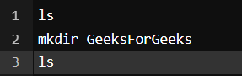

**Output:**

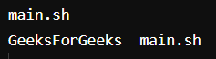

You can see we used ls first to see the directories present there and then **mkdir** to create another directory followed by **ls** to view the created directories.

### **4. cd command**

The [**cd command**](https://www.geeksforgeeks.org/cd-command-in-linux-with-examples/) is used to navigate between directories. It requires either the full path or the directory name, depending on your current working directory. If you run this command without any options, it will take you to your home folder. Keep in mind that it can only be executed by users with [**sudo**](https://www.geeksforgeeks.org/sudo-command-in-linux-with-examples/) privileges.

**Command:**

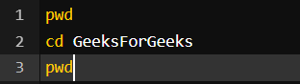

**Output:**

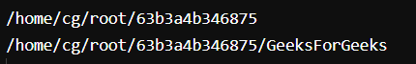

Here we used **pwd** to view the current directory for reference and then we used **cd *GeeksforGeeks***to switch the directory and with again **pwd** command we can see the output is the switched directory, i.e – ***GeeksforGeeks***

### **5. rmdir command**

The [**rmdir command**](https://www.geeksforgeeks.org/rmdir-command-in-linux-with-examples/) is used to delete permanently an empty directory. To perform this command the user running this command must be having **sudo** privileges in the parent directory.

**Command:**

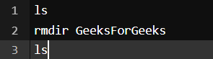

*Command to remove the directory*

**Output:**

**output of rmdir command in linux**

Here we used the **ls** command to check the directories present there and used **rmdir <directory name>** to delete the directory and again the **ls** command to view the directories after deleting the same.

### **6. cp command**

The [**cp command**](https://www.geeksforgeeks.org/cp-command-linux-examples/) of Linux is equivalent to copy-paste and cut-paste in Windows.

**Command:**

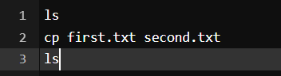

**Output:**

**output of cp command in linux**

Here we used **ls** to view the files and then used **cp** to copy the files of ***first.txt*** to ***second.txt*** and again used **ls** command to view the updated files.

### **7. mv command**

The [**mv command**](https://www.geeksforgeeks.org/mv-command-linux-examples/) is generally used for renaming the files in Linux.

**Command:**

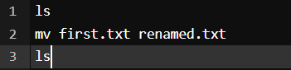

**Output:**

**output of mv command in linux**

Here we used the **ls** command to check the directories and then used **mv <file name> <Renamed file name>** to rename the files, and then again we used the **ls** command to view the renamed file as you can see in the output screenshot.

### **8. rm command**

[**rm command**](https://www.geeksforgeeks.org/rm-command-linux-examples/) in Linux is generally used to delete the files created in the directory.

**Command:**

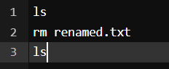

**Output:**

**output of rm command in linux**

You can see as we wrote the **ls** command to view the files in the terminal and then **rm <file name>** to delete the files and again we had the **ls** command to check the update.

### **9. uname command**

The [**uname command**](https://www.geeksforgeeks.org/uname-command-in-linux-with-examples/) is used to check the complete OS information of the system. Check out the command and the output below

**Command:**

**uname command in linux**

**Output:**

**output of uname command in linux**

### **10. locate command**

The [**locate command**](https://www.geeksforgeeks.org/locate-command-in-linux-with-examples/) is generally used to locate the files in the database. Use an asterisk (*) to search for content that contains two or more words. As an example: **locate first*file.** This command will search the database for the files that contain these two names **first** and **file.**

**Command:**

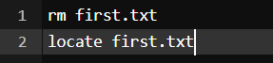

**Output:**

**output of locate command in linux**

We first used the **rm** command to delete the file and then used **locate** command to find the file in the database which in return has given the output with a **-e** as the file was removed.

### **11. touch command**

The [**touch command**](https://www.geeksforgeeks.org/touch-command-in-linux-with-examples/) creates an empty file when put in the terminal in this format as touch **<file name>**

**Command:**

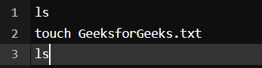

**Output:**

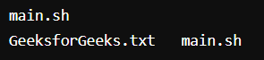

We used the **ls** command to check the current directories in the terminal and then used the **touch** command to create an empty file and then again we used **ls** to find out the created file in the terminal.

### **12. ln command**

The [**ln command**](https://www.geeksforgeeks.org/ln-command-in-linux-with-examples/) is used to create a shortcut link to another file. This is among the most important Linux commands to know if you want to operate as a Linux administrator.

**Command:**

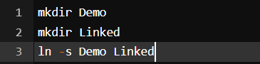

**Output:**

**output of ln command in linux**

Here we used **mkdir** to create two directories and then we used **ln** with an **-s** to create a soft link in it.

### **13. cat command**

The [**cat command**](https://www.geeksforgeeks.org/cat-command-in-linux-with-examples/) is the simplest command to use when you want to see the contents of a particular file. The only issue is that it simply unloads the entire file to your terminal. If you want to navigate around a huge file, should use **less** command alternatively.

**Command:**

**cat command in linux**

**Output:**

**output of cat command in linux**

### **14. clear command**

The [**clear command**](https://www.geeksforgeeks.org/clear-command-in-linux-with-examples/) is a standard command to clear the terminal screen.

**Command:** *This was the terminal before the command.

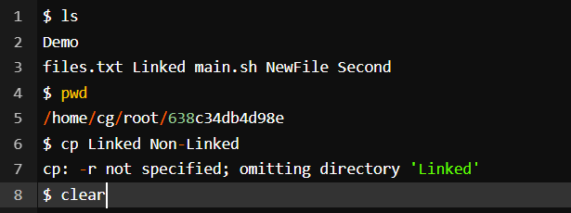

**Output:**

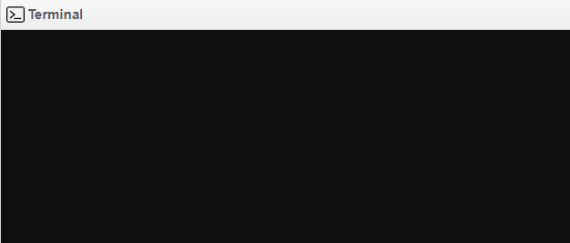

### **15. ps command**

[**ps command**](https://www.geeksforgeeks.org/ps-command-in-linux-with-examples/) in Linux is used to check the active processes in the terminal.

**Command:**

**ps command in linux**

**Output:**

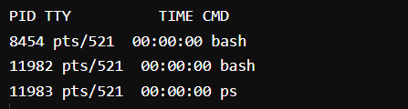

### **16. man command**

The [**man command**](https://www.geeksforgeeks.org/man-command-in-linux-with-examples/) displays a user manual for any commands or utilities available in the Terminal, including their name, description, and options.

Command to view the full manual:

man <command name>

For example, suppose you want to look up the manual for the ls command: **man ls**

**Command:**

**man command in linux**

**Output:**

**output of man command in linux**

### **17. grep command**

The [**grep command**](https://www.geeksforgeeks.org/grep-command-in-unixlinux/) is used to find a specific string in a series of outputs. For example, if you want to find a string in a file, you can use the syntax: **<Any command with output> | grep “<string to find> “**

**For Example:**

cat Files.txt | grep “new”

**Command:**

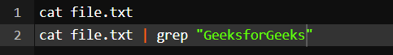

**Output:**

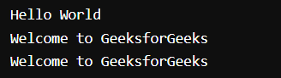

In this command, we first used **cat <file name>** to view the content of the file, and then we used **cat <file name> | grep “string”** to check the string in it.

### **18. echo command**

[**echo command**](https://www.geeksforgeeks.org/echo-command-in-linux-with-examples/) in Linux is specially used to print something in the terminal

**Command:**

**echo command in linux**

**Output:**

**output of echo command in linux**

### **19. wget command**

The [**wget command**](https://www.geeksforgeeks.org/wget-command-in-linux-unix/) in the Linux command line allows you to download files from the internet. It runs in the background and does not interfere with other processes.

Here is the basic syntax: **wget [option] [url]**

**Command:**

wget http://sample.com/sample-menu.php

wget command in linux

**Output:**

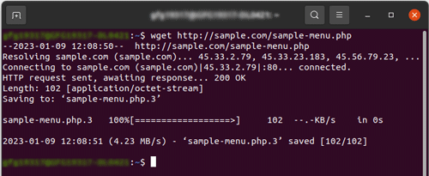

### **20. whoami command**

The [**whoami command**](https://www.geeksforgeeks.org/whoami-command-linux-example/) provides basic information that is extremely useful when working on multiple systems. In general, if you are working with a single computer, you will not require it as frequently as a network administrator.

**Command:**

**whoami command in linux**

**Output:**

**output of whoami command in linux**

### **21. sort command**

The **sort** command is used generally to sort the output of the file. Let’s use the command and see the output.

**Command:** (We are using the cat command to see the file content)

cat command in linux

**Output:** (The content of multiple.txt file in the terminal)

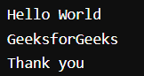

Now we will sort the outcome using the **sort command**

**Command:**

**sort command in linux**

**Output:**

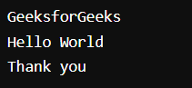

Here first we checked the file content using the **cat** command and then we sorted it alphabetically using the **sort** command.

### **22. cal command**

The [**cal command**](https://www.geeksforgeeks.org/cal-command-in-linux-with-examples/) is not the most famous command in the terminal but it functions to view the calendar for a particular month in the terminal. Let’s see how this works.

**Command:**

**cal command in linux**

**Output:**

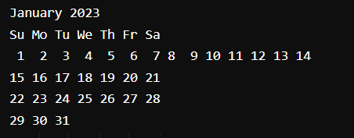

### **23. whereis command**

[**whereis command**](https://www.geeksforgeeks.org/whereis-command-in-linux-with-examples/) in Linux is generally used to see the exact location of any command typed after this. Let’s see how this performs.

**Command:**

**whereis command in linux**

**Output:**

**output of whereis command in Linux**

### **24. df command**

[**df command**](https://www.geeksforgeeks.org/df-command-linux-examples/) in Linux gets the details of the file system.

**Command:**

**df command in linux**

**Output:**

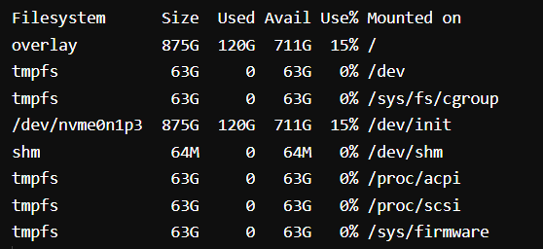

Here we have used **df -h** as simply typing **df** will return the output in bytes which is not readable, so we add **-h** to make the outputs more readable and understandable.

### **25. wc command**

[**wc command**](https://www.geeksforgeeks.org/wc-command-linux-examples/) in Linux indicates the number of words, characters, lines, etc using a set of options.

* **wc -w** shows the number of words
* **wc -l** shows the number of lines
* **wc -m** shows the number of characters present in a file

Let’s see one example of these options

**Command:**

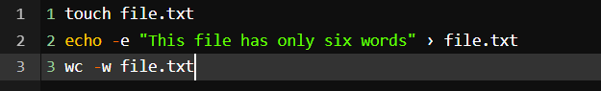

**Output:**

**output of wc command in linux**

Here we used the **touch** command to create a text file and then used the **echo** command to input a sentence that contains six words and we used the **wc -w** command to calculate the number of words in it.